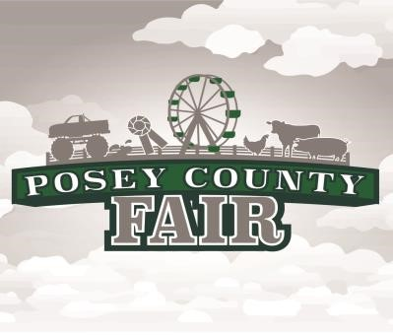

Posey County Fair Association Inc.
P.O. Box 150
Mt. Vernon, IN 47620

Dear Posey County Fair Sponsor,

The Posey County Fair Association, Fair Board Members, and I would like to invite you and your business to sponsor the Posey County Fair. Our sponsorship program will assist us in making the 2024 Posey County Fair another great family event. Some of our major events from 2023 included Carnival Rides, a live Circus, Kid Zone, Professional Rodeo, Tractor Pulls, Truck/Tractor Drags, Outdoor Concert, and Demolition Derby.

Like many Posey County businesses, the Posey County Fair is a time-honored tradition that has served generations of area residents. Like you, we also strive to serve our fair goers to the best of our abilities. In 2024, we are continuing to focus on more opportunities for the entire family that are entertaining and affordable. This year we are looking forward to bigger and better Carnival Rides and Professional Rodeo along with other well-loved events we have had in the past.

We are excited to offer so many free or low-cost events and we need some assistance. Your sponsorship will help provide quality entertainment and educational opportunities for fairgoers. We have enclosed with this letter the sponsorship packages that are available. All sponsors will be recognized at the fair according to their level of sponsorship. There is no better way for your business to showcase itself than by supporting the Posey County Fair and taking part in the Posey County Fair Sponsorship Program! If you have any questions, please feel free to contact me.

Thank you. We greatly appreciate your continued support.

Save the Date for next years Fair
July 15-20, 2024

Best Regards,

Dana Pate |  | Jaina Paciorkowski
Sponsorship Chair |  | Sponsorship Co-Chair
812-459-6153 |  | 812-483-1821
ccc_mom75@yahoo.com |  | patchwrk2@aol.com

Posey County Fair Association Inc.
P.O. Box 150 ۰ Mt. Vernon, IN 47620 poseycountyfair@gmail.com
All donations are tax deductible.

Business Name: _________________________________________________
Contact Person(s): ________________________________________________
Business Address: _______________________________________________
City: ________________________ State: _________ Zip: ______________
Telephone: _____________________________________________________
Email: _________________________________________________________
Sponsor’s Signature: ____________________________ Date: ___________

Sponsorship Amount:

$250 and below - Bronze Sponsor
$500 - Silver Sponsor
$750 - Gold Sponsor
$1,000 and above - Platinum Sponsor

Donation Amount: ________________________________________________

Non-monetary Donation: ___________________________________________

Platinum and Gold sponsors will have logos featured on the sponsorship banner. Silver and Bronze sponsors will have their names included on the banner. All sponsors will be announced at events throughout the fair.

Donations must be received by April 15, 2024 for information to appear on fair advertisements.

Make checks payable to: Posey County Fair Association
P.O. Box 150
Mount Vernon, IN 47620

For questions, please contact sponsorship committee:

Dana Pate Jaina Paciorkowski
812-459-6153 812-483-1821
ccc_mom75@yahoo.com patchwrk2@aol.com

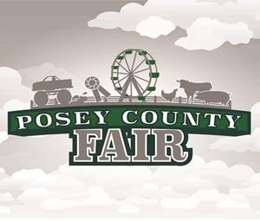

Choose from any of the 6 days of the fair between July 15-20, 2024, to promote your business or campaign. As a sponsor of the day, your name will also go onto all the advertising material developed by the fair. Nights are on a first come, first-serve basis so get your form in early for the best selection.

$3,000 Day Sponsorship
(First come first serve)

- Exclusive sponsorship of a day at the fair - limited to the first six sponsors
- Company website listed on www.poseycountyfair.com
- Company shout out during grandstand events
- Exclusive company recognition on Facebook and Instagram
- Company shout out on the PA system
- Signage provided by the sponsor can be placed at pay gates

o 1st Choice of Day_______________ o 2nd Choice of Day________________ All sponsors will be notified of their winning day

Business Name: _________________________________________________
Contact Person(s): ________________________________________________
Business Address: _______________________________________________
City: ________________________ State: _________ Zip: ______________
Telephone: _____________________________________________________
Email: _________________________________________________________
Sponsor’s Signature: ____________________________ Date: ___________

